Trainer Report: Peer Coach Programme Partners in Learning

Trainer : Nomty Gcaba Date: 23 January 2008 – Session 1

Attendance:
21 Peer educators attended the course. Two management attended the course, but also other three members will also be involved in peer coaching. Educators who attended have different ideas for the course, this resulted to other educators thinking they were there to learn ICT skills. The reason for this is that some of them did not read the invitations, some peer coaches volunteered to go because they wanted to learn how to use computers. This resulted to people asking question that had nothing to do with Peer Coaches and I saw the lack of concentration among other educators when they discover that they are not going to learn how to use computers. Before I start the session, one educator came to me and she said she is panicking and that she was begging me to be patient with her since she doesn’t know much about computers. One educator in particular mentioned that her school already have this program in place and they also coach each other, and she don’t see the need of attending this training when she knows everything about Peer coaching. She said we are teaching them things that they know already.
Two ladies left early because their babies were crying.
Venue
I started the session by making them sit in front and away from computers. The room was big and other computers very far from the table, this was causing a problem with projection of voice; I felt I needed at least the Microphone. There was no enough space for discussion since there is big platform in the middle with desktop and projector, also there was no wall for charts the whole wall is cover by desk with computers.

Session

The Session was flowing nicely and educators becoming more and more involved. Participants enjoyed the discussion where they think of a time that they learned something from a professional development experience that changed their practices as a teacher or principal. Educators from the same school shared their experience with us. This session showed us great qualities amongst peer coaches like good presentation skill, good sense of humour and willingness to take peer coaching forward.

Peer coaches also discussed the characteristics that the Peer Coach should possess so as to be good coach. One peer coaches decided to put this on chart for us. The peer Coaches did not get enough time to use blogs, the reason was that most of did not have email addresses, and also not registered. We started by creating email addresses and unfortunately the internet was slow and one educator only managed to created a email address only. This session took very long since some of them don’t have good ICT skills. Fortunately about 16 of them managed to do the activity but the time was then 03:30 and everyone wanted to leave. There was not time for course evaluations and educators from same schools decided to do this as a group since they were in a hurry but they manage to share their comments.
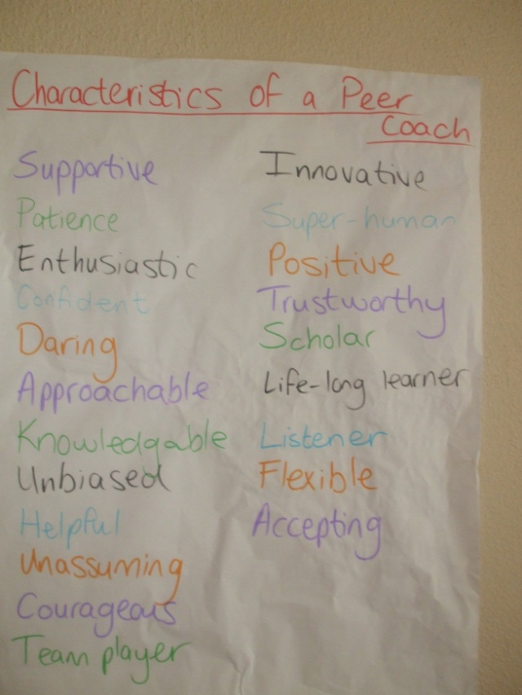

Catering
The food was nice and peer coaches enjoyed lunch.
Next training 15 & 16 March 2008

